Candy’s Story, A Woman’s View of the Model A Hobby!

When I married Mike 25 years ago, I was introduced to his love of restoring vintage vehicles. He had already restored two and was working on one when we met. In fact, we met over a rear end axle for a 1920 White 2 Ton C Cab Truck. Yes, a rear end axle, I bet there aren't too many who can say that! Well the 2 Ton was a little too much so we started a 1927 Model T Ford Roadster. We raised it up as we raised our daughter up. It was definitely a family project and brought many good times and memories.
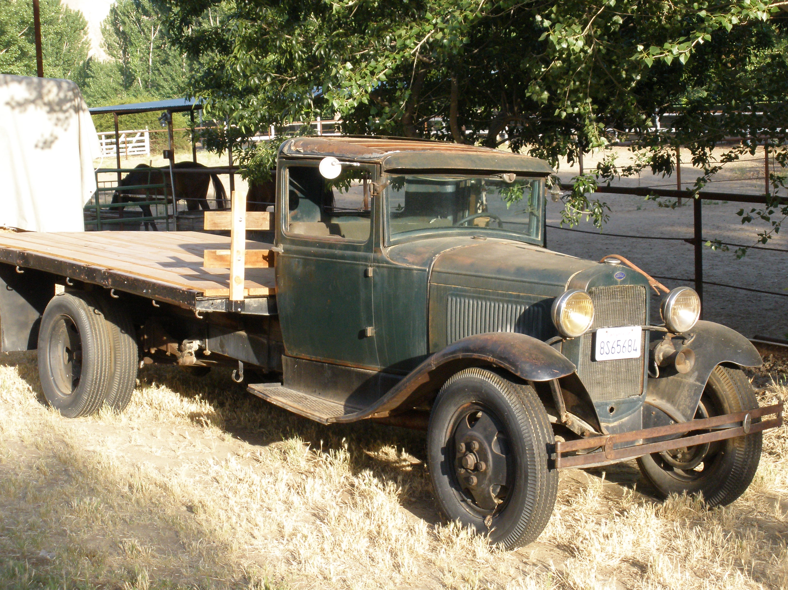
As Alison grew too big to fit between us in the Roadster, it was time to search for a family car with a back seat and a roof. A trip to Las Vegas and our search was over. Along came a 1929 Model A Ford Tudor Sedan, a perfect fit for the Martin family. So the work began and progress was slow because Alison needed a vehicle to drive to school. She wanted a truck and another search began. We found a pretty rough 1945 Ford Pickup and the work began. Alison and Candy learned many new things about cars including getting very dirty trying to squeeze under a truck that is 6" off the ground. The 11th hour of being finished came a few times but finally it was primered and off to school she went. To see the smile on her face the day she drove off to school was worth all the hard work. Her best trick at high school was setting off car alarms as she drove through the parking lots.
Mike & Candy’s Next Project

Once Alison's truck was on the road the work on the Sedan began again. Many hours later and many trips to pick-a-part the Sedan was on the road for a year of driving. Road trips through the Kern Canyon, over the Grapevine and to the coast with the Bakersfield Model A Chapter proved she was very reliable!

Now the hard work of replacing the wood, upholstering and painting has begun. I have learned to sandblast, connect distributor wires, scrape old paint and many other things while restoring vintage vehicles. The time I spend with Mike is precious and the many new friends we have made through our Model A Chapter has been a blessing in our lives.

Candy Martin
Model A Ford Club, Bakersfield

