Know your Vintage?
Do you think you have a pretty good idea of what the1920-1930’s styles look like? Well, I thought I did until I started doing a little research and the result really surprised me. Check it out. The pictures to the right are gleaned from the internet and are a combination of dresses both modern and from the 20-30’s era. Look them over, and see if you can tell which is which! Some are the real deal, the modern ones are vintage inspired or just found in a catalog, but currently available for purchase (although for a pretty penny for a couple of them! Ouch!) The answers are below, so you don’t have to wait to see how you did!
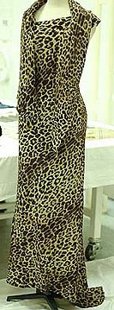
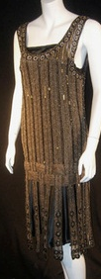
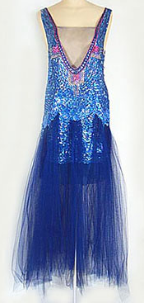
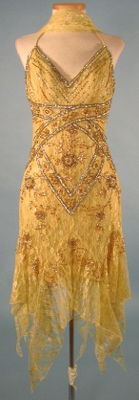
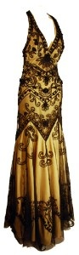
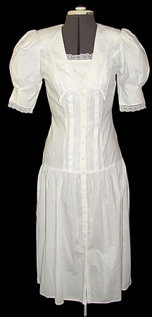
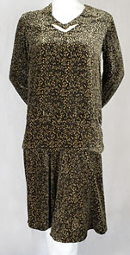
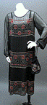
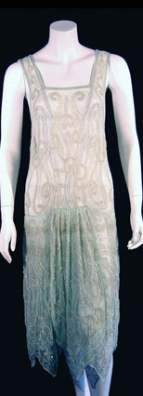
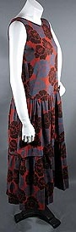
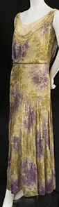
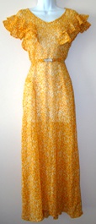
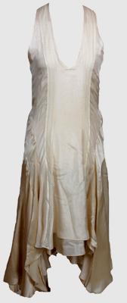
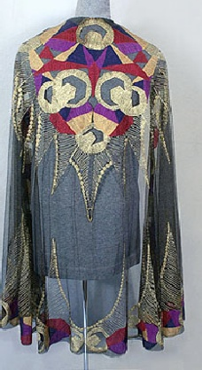
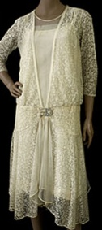
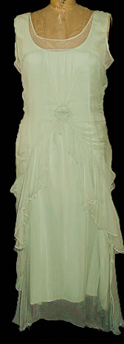
1 2 3 4 5 6 7 8
9 10 11 12 13 14 15 16
KNOW YOUR VINTAGE? Answers 1) New, leluxeclothing.com 2) Old, Early 1920s Dress-pastperfectvintage.com/the20sand30s.htm, 3)New, vintagewedding.com 4) Old, Flapper printed velvet day dress, c.1925-vintagetextile.com/1920s_to_1930s.htm 5) Old, Art Deco silk matte pongee print dress from the mid 1920s-pastperfectvintage.com/the20sand30s.htm 6) New, kaboodle.com7) Old, Couture-quality unlabeled evening dress of sapphire tulle, c.1921-vintagetextile.com/gallery_1920s.htm. 8) New-unique-vintage.com 9) old, Deco silk tulle shawl, embroidered with a bold geometric pattern of metallic gold and silk floss,c.1920.-vintagetextile.com/gallery_1920s.htm 10) New, designersales.biz 11) old, orange floral 1930's dress-propervintageclothing.com/dresses.html 12) New, leluxeclothing.com 13) Silk lace flapper dress, mid 1920s-vintagetextile.com/1920s_to_1930s.htm 14) Old, 1930’s evening dress and mantle in leopard print came from a period when motion pictures with color and sound first hit the big screen. Exotic animal skins worn in the popular Tarzan films made such prints popular in the West.-untoldlondon.org.uk/news/ART62277.html 15) New, vintagewedding.com 16) Beaded lamé evening dress, 1930s- vintagetextile.com/1920s_to_1930s.htm

