Ford Model A body styles
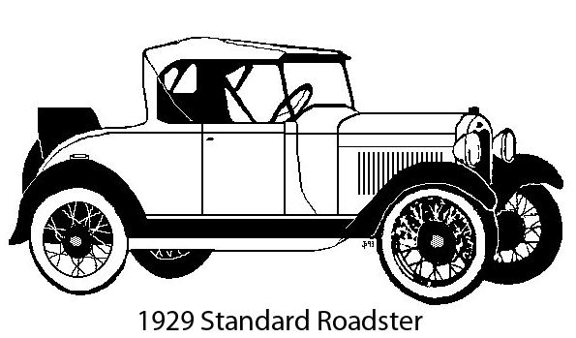
Almost two dozen body styles were available, not including commercial models. The models are standard and deluxe phaeton; standard and deluxe roadster; standard and deluxe coupe; standard and deluxe Tudor (2 door) sedan; standard and deluxe Fordor sedan (Briggs/Murray) and Victoria. Coupe models included Sports and Business coupes. Others were the cabriolet, convertible sedan (A400), , taxi cab, town car (limousine), station wagon, pick-up truck (various styles), AA truck (various styles), and commercial use vehicles.

What shows display antique cars like the Model A?
Many local communities and towns have automobile shows and parades. Check local advertising. The George Washington Chapter Model A Club and the Fairfax County Park Authority conduct a show every Fathers Day at the Sully Plantation, near Dulles International Airport. The Sully car show highlights Model A Fords but includes all cars manufactured before 1973. In 2007, the show registered 378 antique, vintage, and classic cars and trucks. Over 6,000 people attended the event.

Model A factoids
- ⁭ ⁭The Model A Ford came out before the October 1929 Stock Market Crash and was manufactured through the Great Depression. During this period, Henry Ford continued paying his workers $5 a day.
- The 20 millionth Ford car was produced on 14 April 1931. It was a slant windshield Fordor.

What if I am not an experienced mechanic?
Interest in the car is more important than mechanical experience or aptitude. However, there is an extensive body of information available showing ways to repair, adjust, and operate this rather uncomplicated machine. Remarkably, fellow Model A owners enjoy helping others keep them operating.

OK, I am interested in learning more – where can I go?
Several Model A organizations support the hobby. Several are listed below:

⁭Model A Ford Club of America (MAFCA) http://www.mafca.com

⁭Model Restorers Club (MARC) http://www.marc.org

⁭Model A Ford Foundation Incorporated (MAFFI)
http://www.maffi.org
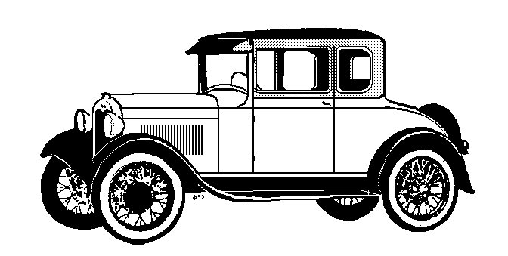
1929 Standard Coupe

The
Model A Ford

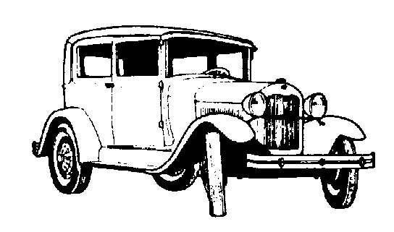
1929 Tudor

1928-1931

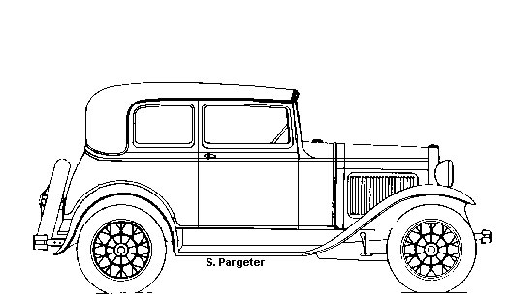
1931 Victoria Coupe
Why do we care about a Model A?

The Model A was the next generation car following the Model T. It provided America with economic transportation continuing a tradition established with the Model T, voted the #1 Car of the 20th Century. Henry Ford started the Ford Motor Company in 1903 and produced the Model T from 1908 to 1927. The Ford Model A production began in October 1927 and continued through March 1932.

Why is it called a Model A and not a
Model U, the follow-on to the Model T?

In developing cars, Ford identified model design by a letter. Ford produced the first Model A in 1903, and it was followed by other models such as the Model B and C (1905), the Model K and N (1906). They stopped changing the model number with the Model T. Ford wanted to break from tradition and begin anew. Initially, the Model A was simply called ‘the New Ford”. For some reason, they decided Model A was most apt. The1932 cars had the first Ford V8 engine available as an option. The 4 cylinder cars were called Model B. After that, the design changed each year, negating the need for naming models by letter.

How fast will it go?

A ‘stock’ Model A in good mechanical condition will cruise all day at 45-50 miles per hour. Modified cars with after-market overdrives can cruise at 60 mph or more depending on other modifications.
What are the features of the Model A?

4 cylinder engine, 40 horsepower, water cooled, internal combustion
Four wheel mechanical brakes
About 2 dozen different models were available, excluding commercial models
⁭Safety features included safety glass, brake light, bumpers, ammeter, and fuel gauges; fuel shut off in the passenger compartment, etc.

How much did they cost when produced and how much are they now?

When produced, a new Ford Tudor Sedan (2 door) cost from $495-$525. A roadster was the cheapest ranging from $435-520 depending on the year and options desired. The most expensive was the rare, Town Car (limousine) at $1,200. Presently, one can purchase a running car, called a “driver” for $6,000-$10,000. Models that are more desirable cost more. Show cars can range from $25,000 to $40,000. Rare, original models cost the most. You can buy them on eBay, but look over the car with the assistance of a knowledgeable person.

How does this car pass state emission and safety examinations?

Antique cars normally are only required to have the operating safety equipment and meet emission requirements that were in effect at the time of manufacture. If a car is registered using historical vehicle plates, it is subject to different rules of use and safety standards.
Why do people want to own Model A’s?

In addition to being a significant part of history, they are a novelty that brings a smile to many faces. They are simple to work on and fun for those who enjoy working on mechanical things. Car clubs offer camaraderie and appreciation of the era and its rich history. Many Model A owners drive cars handed down by their families as heirlooms. Many owners participate in community events in parades and displays, an enjoyable pastime. Others enjoy touring the countryside in these venerable machines.

Where can you find parts for Model A’s?

Surprisingly, it is not too hard to find parts. Many reproduction parts and specialty supply companies offer new or reconditioned car parts. One can purchase items such as new bodies or fenders for different models. Other companies rebuild engines, transmissions and other components. There are many clubs nationwide, and members frequently help one another in restoring or repairing these cars. Flea markets often yield parts.

Are these cars still available to potential buyers?

Yes. Some estimate that 250,000 Model A’s still exist, some as complete cars, others in various stages of disassembly. Antique car publications and sometimes newspapers list Model A’s for sale.

