Warm Furs for Winter
By Patti Jones

(Taken from the 1931 Cownie Tanning Co. Catalog)

Winter is fast approaching and what better way for a Model A woman to keep warm but to cuddle up in a fur coat. These 4 styles of fur coats cover all outdoor activities you might take in.

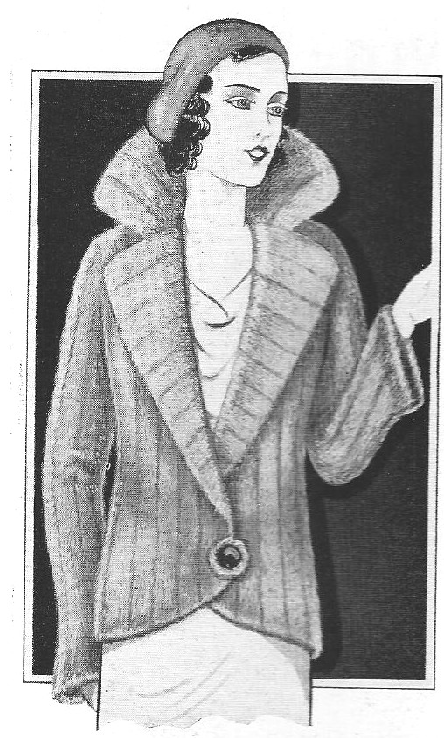
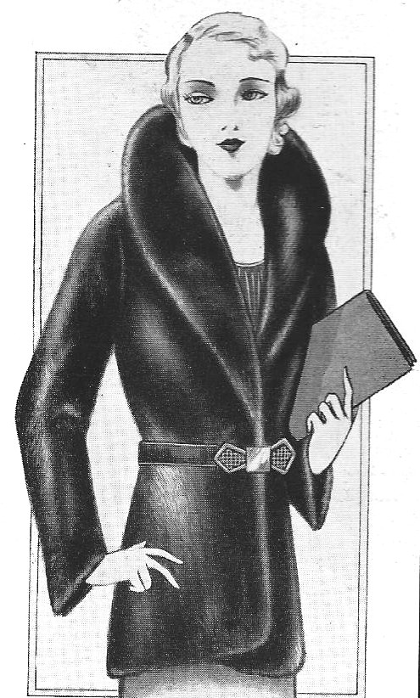
(A) This short coat is designed for street wear as well as going out for dinner. This type of collar is called a French Johnny collar, has a semi-flared tailored sleeve, and a single button attached low to the bottom of the coat. It could be purchased in muskrat or rabbit pelts.
(B) The short coat is ideal for a night out on the town. It’s made from black seal and can be worn with or without the belt.

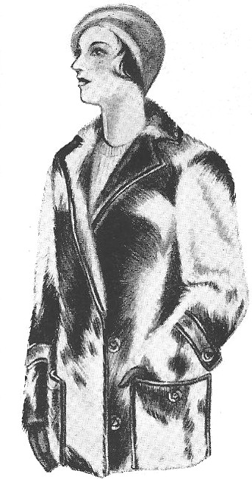
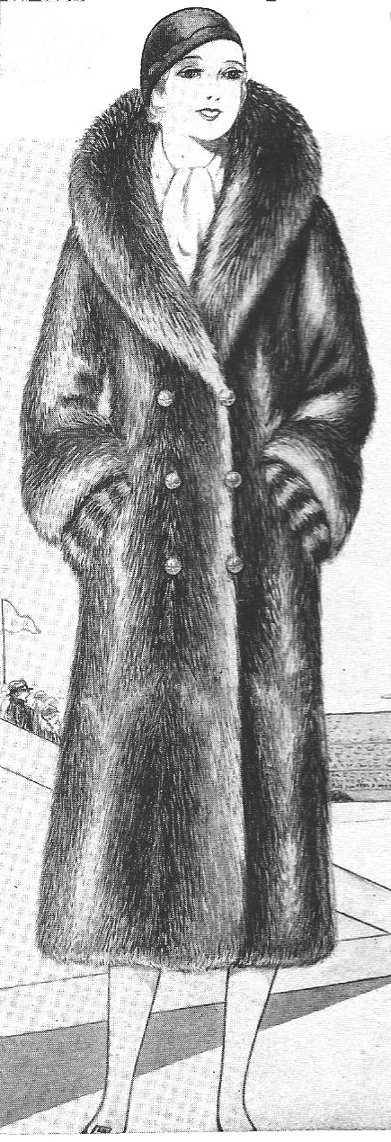
(C) This style of coat can be worn just walking down the street or up in the stands rooting for your favorite football team. It’s made of calf skin, has 2 deep pockets, belted sleeves and is trimmed with leather.
(D) This is your typical “raccoon coat” for sports and general wear. It has a large full collar, with leather buttons and lined with either silk or wool for added warmth.

In my 40+ years of collecting, I have run across only the raccoon coat (D). A couple of hints when looking at fur coats:

Be sure that that the pelts are not stiff or dry. If they are, the coat will deteriorate very quickly. Check that the stitching between pelts is solid. Furriers used heavy silk thread and over the years the thread does deteriorate. The pelt might be good, but may have come apart from the one next to it.

Do not store any of your furs in plastic bags. Instead, cover your fur with a cotton sheet or pillowcase. Because your body oils will deteriorate and mat the fur, I typically brush out any fur coat/pelt that I have worn close to my neck before I put it way.
Winter Wear for that Bridge,
Luncheon or Tea Date
By Patti Jones

(Taken from the January 1931 Ladies’ Home Journal)

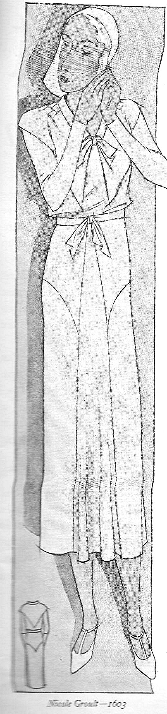
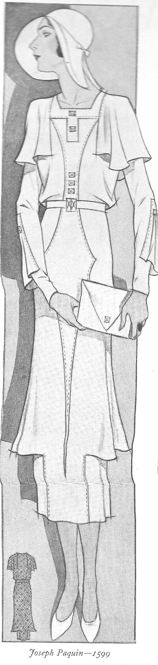
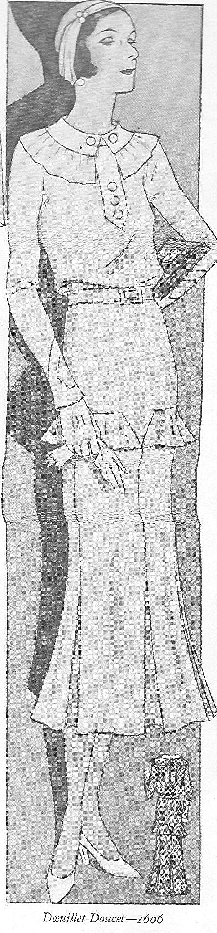
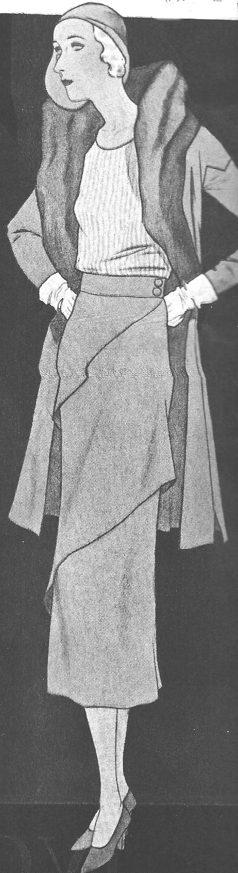
I selected these 4 styles as typical of 1931. The mid 30’s peplum rage was starting to make its way into the fashion scene in 1931.
(C) This dress has had an unusual round collar and tab neckline. The flounces on the hip gave the dress a “tunic” affect, and came in black silk faille and black and white diamond pattern.
(B) This style of dress is very unusual because of the cap sleeve used with long sleeves. Notice the detailing of the flair on the arm, and the detailed panels in the front of the dress. It came in a dark green silk faille and was accessorized with a green envelope purse and large green felt hat.
(D) This is my favorite outfit! Designer Schiaparelli designed this 3 piece suit in a deep mulberry monotone tweed. The silk blouse is a shade lighter, and the big shawl collar of the jacket is trimmed in beaver. The diagonal tiers on the skirt gives a slimming affect to the wearer. The ensemble is complemented with brown opera pumps.
(A) This sleek-lined afternoon frock echoes the pointed cape collar and the pointed skirt yoke. This versatile dress is made in crepe de chine of a delicate heliotrope (violet), trimmed in light blue.
# # # # # # #

