MAFCA

For

NATIONAL, DIVISIONAL AND REGIONAL MEETS

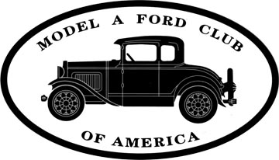

COMPILED BY THE MAFCA JUDGING STANDARDS COMMITTEE
Updated 6/2005

TABLE OF CONTENTS

Introduction 3

Chief Judge Responsibilities 4

Judging Coordinators Responsibility 6

Judging Guidelines 8

Tool Inventory List 11

Ford Model A Body Types 12

Classes and Awards 14

Official Judging Sheets 15

Final Judging Score Sheets 17

Modified Judging Score Sheets 43

Window Placard 51

National Final Judging Requirements 52

Quality Assurance Check Off List 53

MAFCA Judge Evaluation Form 54

INTRODUCTION

This manual is provided as a supplement to the Model A Ford Judging Standards and Restoration Guidelines to assist the Chief Judge and the Host Judging Coordinator in preparing for and conducting the Model A Ford judging event at a national meet. These procedures are also recommended for divisional and regional events at which car judging is planned to be in accordance with the MAFCA standard.

The recommended duties of the Chief Judge and the Host Judging Coordinator are presented as well as a list of judging guidelines based on the suggestions received from the principals of recent events. A list of all Model A body styles arranged by body type number is included as a convenient reference. A copy of the one-page Judging Classes & Awards mailer as seen in The Restorer prior to the Kansas City National Meet is included for use in future events.

Samples are included of all forms necessary to carry out the event. It will be necessary to edit the headings to adapt many of these for use at your specific event. The individual scoring sheets are to be printed with colored paper according to the class – blue for Restored, white for Original, red for Touring and green for Modified.

Copies of all MAFCA policies affecting Model A judging are included for reference. Regional and certain divisional events may be organized without strict conformance to these policies. In these cases, judging advancement credit may not apply.

The successful completion of the “safety inspection” or “safety check” referred to in this manual, as well as the Model Ford Judging Standards and Restoration Guidelines, does not imply road-worthiness of the vehicles involved.

It is hoped that the procedures and material included in this manual will be helpful in the planning of a successful Model A car judging event at your meet. If you have any questions or recommendations for improvement, please send them to the Judging Standards Committee at the MAFCA business office at 250 South Cypress Street, La Habra, California 90631-5586.

This manual was compiled by the 2000 MAFCA Judging Standards Committee:
Jerry Hoxsie (Chairman), Burbank, CA
Ron Accornero, Alameda, CA
Steve Breiting, Puyallup, WA
Bill Cote, (Chief Judge – Kansas City), Pine Grove, CA
Ross Milne, Brampton, Ontario
Robert Trousil, Downey, CA

CHIEF JUDGE RESPONSIBILITIES

AT A NATIONAL, DIVISIONAL OR REGIONAL MEET

These duties are amendable according to local circumstances, but, in the main, spell out most of the details involved in the task of being a Chief Judge at a national, divisional or regional meet where vehicle judging is to take place and the certification of judges is to follow. The Chief Judge should be a Master Judge and a member of MAFCA who does not need to be a member of the host chapter(s).

Acquiring a Chief Judge

Acquiring a Chief Judge for your national, divisional or regional meet can begin with the MAFCA Judging Standards Committee (JSC). Address your inquiry to the committee c/o the MAFCA Office. For regional and divisional meets, the JSC can provide you with a copy of currently certified and active judges and can, if you desire, recommend some names for you to consider. For national meets, the policy requires that the MAFCA Board approve the selection of the Chief Judge who, in turn, works closely with your host coordinator in order to have a successful, educational and professional vehicle judging experience at your meet.

Expenses

Expenses involved in the Chief Judge's duties are primarily the mailing and phone calls expenses that the Chief Judge will entail arranging for judges and the assignments and for vehicle entries and matters pertaining thereto. The host chapter(s) in their budget should make provisions for reimbursement to the Chief Judge for these costs. At national meets, MAFCA has in the past authorized an entry fee for vehicles being judged to help defray some of the costs involved.

General Responsibilities

The Chief Judge has the overall responsibility to see that the car judging is carried out in accordance with the Model A Judging Standards and Restoration Guidelines. This includes establishing a complete understanding with the host chapter Judging Coordinator of the requirements and responsibilities necessary to assure the planning and follow-through for a successful event. It should be remembered that we judge Model A's to:
1. Support the restoration of this classic vehicle.
2. Continue to educate the participating judges on the various areas of restoration.
3. Give recognition to the Model A owners for their efforts in restoration.

Specific Responsibilities

The specific responsibilities of the Chief Judge are as follows:
1. As Chief Judge, not to personally judge any of the Model A's, but to be the single point of authority for the management and control of vehicle judging. At national meets, the Chief Judge is a voting member of the Judging Standards Committee while serving as Chief Judge.
2. Receives from the Judging Coordinator, the names and addresses of individuals requesting to judge, determines the number of judges to be assigned to each judging area and notifies individuals of their area of responsibility. This notification is made well before the meet to allow the necessary time for the individual to study and prepare himself/herself for the assigned judging area.
3. Determines which judges will be assigned as the Team Captains and their assigned area of responsibility. Supplies the Team Captains with a list of judges assigned to their team.
4. At national meets, publishes in The Restorer the "Model A Classes & Awards", a one-page review of the car judging requirements for the upcoming event. This is published as early as possible to assist those who may enter their vehicles for judging.
- Makes available to the host chapter Judging Coordinator a sample of all the
necessary forms that will be used to facilitate the judging process.
- At national meets, keeps the Vice President of MAFCA apprised of the judging
Program as planned and of any significant changes or additions thereto.
- Investigates the proposed judging site to determine suitability and layout.
- Determines the feasibility, date, time, and route of the mandatory tour.
9. Establishes a time in the meet schedule for a judging seminar, judges’ meeting, and, if possible, preliminary judging team training on a day prior to actual judging. At the judges meeting, the Chief Judge will discuss all the basis elements of good judging; the allotted time for judging each vehicle; and any other special matters pertinent to this particular meet. If time permits, a car owner’s meeting is suggested to answer last minute questions on procedures, etc.
- Coordinates the scheduling of the photography of the cars by the host chapter for
use on the trophies, for a slide presentation at the banquet or for a possible article in The Restorer
- Reviews the score sheets and tally results to determine that there is no uneven
judging or deviation from the basic philosophy outlined in the judges’ meeting or in the Judging Standards.
12. Releases the team captains after verifying all vehicles in their area have been judged and that all judging sheets are complete.
13. Oversees the selection and preparation of the tally committee by the host chapter. Verifies that the tabulation of scores is accurate and complete.
- Makes trophy determinations after all scores are double-checked and coordinates
the awarding of trophies.
15. Maintains the confidentiality of the judging scores.
- Assures that within 30 days after the meet the score sheets are distributed to each
entrant.
17. Provides the Judging Standards Committee a complete list of judges who participated in the meet, their area of responsibility and a complete list of cars judged with a copy of the score and tally sheets. Includes the Judge Evaluation forms to the JSC for their review and records. The JSC will retain the score sheets for one year.
18. Writes a "Thank You" letter to all judges and key support personnel.
- Provides a written summary of the judging event to the MAFCA Vice President
(national meets) or the host chapter (divisional and regional meets) with a copy to the JSC. This report should be a critical analysis for use at future meets.
Provides a list of all trophy winners to The Restorer Editor.

JUDGING COORDINATOR RESPONSIBILITIES

AT A NATIONAL, DIVISIONAL OR REGIONAL MEET

The Judging Coordinator(s) shall be a MAFCA member and for national meets shall be designated by the host group and approved by the Chief Judge. For regional and divisional meets, the approval of the Chief Judge is not required. The Judging Coordinator does not need to be a certified judge. He/she acts as the liaison between the hosting group and the Chief Judge for the Model A judging program, handling all administrative and clerical tasks.

Specific Responsibilities

The specific responsibilities of the Judging Coordinator are as follows:
1. Assures that the Chief Judge receives all the names and addresses of those requesting to judge and of those who wish to enter their vehicles for judging.
2. Proposes a site and layout of the final judging area for the Chief Judges' approval.
3. Coordinates with the Chief Judge and produces all necessary printed forms and supplies.
4. Recruits and organizes all support personnel to the judging process.
- Provides for security of the vehicles being judged and all materials needed in support of the judging process.
6. Provides for a secure space near the judging area for the judging of tools.
7. Provides for a secure room near the judging area for tallying the score sheets.
8. Provides for judge’s hats or ribbons for security identification during event.
9. Provides photographic coverage of each vehicle entered for judging. A copy of each photo of those placing 1st place or above shall be forwarded to the Editor of The Restorer (This applies to national meets only).
10. Arranges for lunch and refreshments for the judging teams during the judging process.
11. Provides in the registration packet for vehicle entrants, the pertinent information as to where, when and how the prejudging, safety check, photographs and staging of the vehicles for judging will take place.
12. Makes arrangements and supervises any subsequent show of the judged vehicles.
13. Arranges for the vehicle award trophies and oversees the part of the awards banquet that features the vehicle awards. At many meets, the awards trophies are designed, budgeted and produced by a special committee of the host chapter as they are also required for other events.
- Forwards the judging sheets to all entrants within 30 days after the meet.
- Writes a summary of his/her experience and forwards it to the national office for
use of future Judging Coordinators (This applies to national meets only).

Budget Items

Budget items include the following:
- Printed forms (see list).
- Postage, FAX and telephone expenses.
- Chief Judge expenses (postage and telephone calls).
- Supplies (see list).
- Refreshments and meals for judges and support personnel.
- Distinguishing hats, etc. for judges and support personnel in the judging area.
- Space rental and preparation expense.
- Sanitation facilities (where applicable).
- Security, fire extinguishers and other safety items.
- Computer system (for scoring tally sheets).

Printed Forms

The following printed forms are to be reproduced in quantities, color and paper weight as described (samples of each are included in the Judging Procedures Manual):
1. "Official Model "A" Ford Judging Sheet" (pages 9 & 10 of the Judging Standards). One/vehicle (min.), white, standard weight paper
2. (9) Individual Area Judging Sheets, Team A through I. One/vehicle (min.), colored paper (blue - blue ribbon vehicles, red - red ribbon vehicles, white - white ribbon vehicles and green - green ribbon vehicles, standard weight paper. Pre-print meet information.
3. Window Placard (pages 7 & 8 of the Judging Standards). One/vehicle (min.) printed front and back, white, heavy card stock paper.
4. "Request to Judge Form". One/judge (min.), white standard weight paper. Pre-print meet information.
5. "Car Entry Form". One/vehicle (min.), white standard weight paper. Pre-print meet information.
6. "Quality Assurance Check Off List". One/20 vehicles (min.) white standard weight paper.
7. "Tool Inventory" form. One/vehicle (min.), white standard weight paper.
8. "Judge Evaluation" form. One/judge (min.), white standard weight paper.

In addition to the above, the Judging Coordinator will need to provide a "Judges Information Sheet" describing the procedures, meals, refreshment, safety requirements, smoking rules, sanitation facilities, etc., and a "Vehicle Owner Information Sheet" describing a schedule of events with times, locations and other general information pertinent to the judging procedure. The Chief Judge should approve these sheets.

Supply List

It is suggested that a supply list be prepared for those items found to be of assistance during the judging process. These items include:
- Clipboards (for the team captains). 2. Pencils and marking pens.
- Flashlights. 4. Oil Drip mats.
- Cardboard (for undercarriage judges). 6. Duct tape.
7. Masking tape. 8. Staplers.
9. Large paper clips. 10. Soft clean rags (one bundle).
11. Full sized envelopes (one/car min.). 12. Postage stamps.

In addition to the trophies, award ribbons in the appropriate color are required for each vehicle (blue for Restored, white for Original, red for Touring and green for Modified).

RECOMMENDED MODEL A FORD JUDGING GUIDELINES

AT A NATIONAL, DIVISIONAL OR REGIONAL MEET

All aspects of the Model A Ford judging process at a national, divisional and sanctioned regional meet shall be carried out in accordance with the Model A Judging Standards and Restoration Guidelines

Judges Meeting

A judge's meeting is recommended before the day of final judging in order to brief the judges on specific variations applicable to the meet as well as to review proper conduct, ethics, fairness and responsibilities. Team captains should assemble their teams after the meeting for specific procedural instructions and team training. This may include actual practice judging on a few cars if available. A brief second judge's meeting is suggested on the morning of final judging to make last minute announcements, answer any remaining questions and to verify that all judges are assembled and ready to begin judging.

Preliminary Judging

Preliminary judging includes the 14 point judging and the classification of vehicles (restored, original, touring and modified), the safety check, "Start and Idle" (area 21) and the working order portions of "Lamps" (Area 18), "Horn" (Area 19) and "Windshield Wiper" (Area 20). It is recommended to begin the prejudging process just prior to the final judging. Once classified, vehicles in the modified class will be judged on a separate scoring sheet (green) which includes two prejudge categories, "Start and Idle" (Area 1A) and "Safety Check" (Area 1B). It is important that the details of this procedure be understood by those judges assigned to this task. At large meets, it is advised to provide two or more lines with the modified vehicles, once classified, to be processed separately. Vehicle owners must be informed in advance, in writing, as to where and when prejudging will take place and what they are expected to do

Final Judging

As above, instructions should go to owners well in advance as to precisely when and where final judging will take place and what is expected of them including details regarding the windshield placard, hood latches, side curtains, etc. (see "Instructions for Car Judging Entrants"). Variance Authorization Letters are to be taped to the windshield during judging. This information can be contained in the confirmation letter from the Judging Coordinator. Owners will stay in their vehicles until they are parked in their final judging location. Vehicles should be parked together by their classification, i.e., restored, original, touring and modified with adequate aisle space (60" minimum) to allow access to the undercarriage and free movement of judges. Oil mats and other safety requirements (fire extinguishers, gas cap covers, battery disconnects) as may be required must be in place during the time the vehicles are in the final judging location. Allow a reasonable time for the owner of a vehicle to take care of last minute business (a final wipe down, etc.) before beginning the final judging. The public is restricted from the final judging.

Photographs

It is recommended that photographs of vehicles and their owners entered in the final judging be taken just prior to entering the final judging location.

Judging of Tools

Tools can be judged in three different manners: during the prejudging (preferably without the owner overhearing the comments), with the tools displayed in front of each vehicle during the final judging or in a separate area with a strict security procedure. A separate area provides the benefit of security in that tools can be checked in and out by each owner (see Tool Inventory form) and the use of a video taping.

Public Viewing

When possible, it is suggested that a period of time be set aside for public viewing of the vehicles after the final judging has occurred. This also gives the owners an opportunity to view their vehicles in the company of the others. Security personnel are recommended to remind the visitors of the rules not to touch, etc.).

Clearing the Final Judging Area

Owners are responsible for returning at a pre-established time to retrieve their vehicles after the final judging.

Mandatory Tour

A check off system (at one or more points along the route) should be planned to ensure that all vehicles participating in final judging are driven on the mandatory tour. If local and safety conditions warrant, the mandatory tour can be a part of the scheduled grand tour. The Chief Judge is responsible for determining how, when and where the tour is to be conducted or determining that a mandatory tour will not be conducted.

Trailer and Car Parking

Owners must be informed before or when they arrive as to where they will be able to park their trailers and their Model A's.

Score Sheets

Score sheets for each vehicle will be placed on the front seat prior to the final judging. During the final judging, the Team Captain will pull the appropriate sheet, make the score entries, sign the sheet when completed and forward the completed sheet to the tabulator as directed. A check-in table is located nearby for this purpose with runners collecting the sheets from the Team Captains. The Quality Assurance Check Off List (see form) is used by a tabulator assistant to confirm the score entries, the "code red" entries and Team Captain signature. The score sheet is then given to the tabulator for final entry.

Dismissal of Judges

Judges should not be dismissed until the responsible Team Captain and the Chief Judge have verified that all vehicles have been judged and all of the score sheets are complete. Team Captains should not be dismissed until the Judge's Evaluation sheets are completed (see form).

Scores

The judges shall not tabulate the scores. Tabulation is to be done in an area off limits to judges and the public.

Disputes

In the event there is a participant dispute, the Chief Judge shall serve as the contact and spokesman for the judges. Individual judges may be required to defend their judgment, as it pertains to a specific instance of judging, to the Chief Judge.

Inclement Weather

Alternate plans or arrangements should be made in advance to protect the vehicles, owners and judges in case of inclement weather.

Conflicts in Scheduling

Every effort should be made to avoid scheduling conflicts with other major events. Owners are encouraged to participate in all events. Entering a vehicle in final judging should not prevent owners from enjoying major tours, era fashion judging or gymkhana if at all possible.

Vehicle Preparation Area

If facilities permit, an area of appropriate size should be designated where owners can prepare their vehicles for judging. Owners should be informed as to the location and when the area will be available for their use.

TOOL INVENTORY LIST

This Tool Inventory List is part of the security procedure taken to protect your tools during the judging process.

If you are entering your tools for judging, please indicate below which items you are entering. Place an “X” next to the listed item that is in your tool inventory, then sign and date this form. This form will remain with the tool judging team during the judging process.

Please pick up your tools after your car have been released by the Chief Judge.

Provide the Month ________ Year _________ Model _________ of your car/truck.

Registration No. __________

_____ Owner’s Manual _____ Small Open End Wrench

_____ Tool Bag _____ Large Open End Wrench

_____ Grease Gun _____ Adjustable Wrench

_____ Screwdriver _____ Spark Plug Wrench

_____ Pliers _____ Jack

_____ Crank _____ Jack Handle

_____ Tire Iron _____ Oil Can (BOP until May ’28)

_____ Tire Pump

Print Name ___________________________

Signature _____________________________ Date _______________

Signature of person picking up tools _______________________________
NUMERICAL LIST OF FORD MODEL A BODY TYPES

BODY TYPE NAME YEAR
35-A Phaeton (Std) 1928-29
35-B Phaeton (Std) 1930-31
40-A Roadster (Std) 1928-29
40-B(Std) Roadster (Std) 1930-31
40-B(Dl) Roadster (DeLuxe) 1930-31
45-A Coupe (Std) 1928-29
45-B(Std) Coupe (Std) 1930-31
45-B(Dl) Coupe (DeLuxe) 1930-31
49-A Coupe (Special) 1928-29
50-A Coupe (Sport) 1928-29
50-B Coupe (Sport) 1930-31
54-A Coupe (Business) 1928-29
55-A Tudor Sedan 1928-29
55-B Tudor Sedan 1930-31
60-A Fordor (leather back seal brown top-Briggs) 1928-29
60-B Fordor (leather back black top (Briggs) 1929
60-C Fordor (steel back) Briggs 1929
66-A DeLuxe Pickup 1931
68-A Cabriolet 1929
68-B Cabriolet 1930-31
68-C Cabriolet (slant windshield) 1931
76-A Cab (open) 1928-30
76-B Cab (open) 1930-31
78-A Pickup 1928-31
78-B Pickup 1931
79-A "A" Panel Delivery 1928-30
79-B "A" Panel Delivery 1930-31
82-A Cab (closed) 1928-30
82-B Cab (closed) 1930-31
85-A "AA" Panel Delivery 1928-30
85-B "AA" Panel Delivery 1930-31
88-A Platform 1928-30
89-A Express 1928-30
130-A DeLuxe Delivery 1928-30
130-B DeLuxe Delivery (Standard & Drop floor) 1930-31
134-A Stock Racks 1928-30
134-B Grain Sides 1928-30
135-A Taxi Cab 1928-29
140-A Town Car 1928-29
140-B Town Car 1930
150-A Station Wagon 1929-30
150-B Station Wagon 1930-31
155-A Town Sedan (Murray) 1929
155-B Town Sedan (Briggs) 1929
155-C Town Sedan (Murray) 1930-31
155-D Town Sedan (Briggs) 1930.31
160-A Fordor Sedan (Std) 1931
160-B Town Sedan 1931
160-C Fordor Sedan (DeLuxe) 1931
165-A Fordor Sedan (Std)(Murray) 1929
165-B Fordor Sedan (Std)(Briggs) 1929
165-C Fordor Sedan (Std)(Murray) 1930-31
165-D Fordor Sedan (Std)(Briggs) 1930-31
170-A Fordor Sedan (Std)(2-window) 1929
170-B (Std) Fordor Sedan (Std)(2-window) 1930
170-B (Dl) Fordor Sedan (DeLuxe)(2-window) 1930-31
180-A Phaeton (DeLuxe) 1930-31
185-A Platform (157" wheelbase) 1930
185-B Platform (157" wheelbase) 1931
186-A Stake 1930
186-B Stake 1931
187-A Platform (131 -1/2" Wheelbase) 1931
188-A Stake 1928-30
189-A Stake 1931
190-A Victoria 1930-31
195-A Express Body (131-1/2” wheelbase) 1931
196-A Canopy Top (for 195-A) 1931
197-A Express Body (157" wheelbase) 1931
198-A Canopy Top (for 197-A) 1931
199-A Ice Wagon (Large) 1931
200-A Hand hoist dump body assembly (Anthony) 1930
200-B Dump body with hand hoist (1-1/2 cu. yd. capacity) (Galion)
201-A Coal body with heavy hydraulic bout and end gate with chute 1930-31
(less swinging partition) (75 cu. 1l) (Galion)
201-B Coal body with heavy duty hydraulic hoist, swinging partition and
end gate with chute (high end) (75 cu. ft or 120 cu. ft. with sides) (Wood)
201-C Coal body with heavy duty hydraulic hoist. And 1930-31
end gate with chute (less .winging partition) (75 cu. 1l) (Wood)
202-A Gravity dump body assembly (Anthony) 1930
202-B Gravity dump body (1-1/2 cu. yd. capacity (Wood) 1931
203-A Garbage body with heavy hydraulic hoist (2 cu. yd. capacity) (Galion) 1930-31
203-B Garbage body with heavy hydraulic hoist (2 cu. yd. capacity) (Wood) 1930-31
203-C Garbage body with heavy hydraulic hoist (3 cu. yd. capacity) (Wood) 1930-31
203-D Garbage body with heavy hydraulic hoist (3 cu. yd capacity) (Wood) 1930-31
204-A Dump body with light hydraulic hoist (1-112 cu. yd. capacity) (Galion) 1930-31
204-B Dump body with light hydraulic hoist (1-112 cu. yd. capacity) (Wood) 1930-31
205-A Hi-Lift. Hydraulic Coal Body (72 cu.1l) (Wood) 1930-31
200-A Dump body with Rotary power hoist (Anthony) 1930
200-B Dump body with mechanical hoist (1-112 cu. yd. capacity) (Detwiler) 1931
207-A Combined dump and coal body with heavy hydraulic hoist (Galion) 1930
207-B Combined coal and coke body with high sides and end gate with 1930-31
chute opening and swinging partition with heavy hydraulic hoist
(120 cu. ft. capacity) (Wood)
208-A Dump body w/heavy hydraulic hoist (1-112 cu. yd. capacity) (Galion) 1930-31
208-B Dump body w/heavy hydraulic hoist (1-1/2 cu. yd. capacity) (Wood) 1930-31
210-A “AA” Panel Delivery 1931
225-A “A” Panel Delivery (with drop floor) 1930-31
228-A Stock Racks 1931
229-A Service Car 1931
236-A Light hydraulic hoist and body under structure (Galion) 1930-31
237-A Heavy hydraulic hoist and body under structure (Galion) 1930-31
237-B Heavy hydraulic hoist arid body under structure (Wood) 1930-31
238-A Stock Racks 1931
239-A Meat Packers Express 1931
242-A Heavy Duty Express Body (131-1/2” wheelbase) 1931
255-A Special Delivery (Natural wood) 1931
270-A Funeral Service 1931
275-A Funeral Coach 1931
280-A Ambulance 1931
285-A Police Patrol (DeLuxe) 1931
290-A Police Patrol (Std) 1931
295-A Town Car Delivery 1931
300-A DeLuxe Delivery 1931
330-A School Bus 1931
400-A Convertible Sedan 1931

The establishment of the car judging classes have been determined by the MAFCA Judging Standards Committee the 2000 Kansas City National Meet.
The ISC has reviewed the last four national meets and made changes to reflect the current revisions in the Judging Standards and in the Touring and Modified classes. The intent is to allow for the maximum number of cars to participate in the car judging process. There will be four classes, Restored (Blue Ribbon), Original (White Ribbon), Touring (Red Ribbon) and Modified (Green Ribbon). All car judging will be conducted using the 1997 updates.
MODEL A FORD JUDGING CLASSES & AWARDS
2000 MAFCA NATIONAL MEET - KANSAS CITY, MISSOURI
BY BILL COTE, CHIEF JUDGE

A "Best of Show" award will be awarded to the vehicle ring the highest points. An "Award of Excellence" will be given to the vehicles in the Blue, Red and White ribbon classes that score the appropriate points.

RESTORED BLUE RIBBON
Vehicles that have been restored to original condition and represent the Model A as it came from the factory. Vehicles must meet all of the 14 points as outlined in the Judging Standards and Restoration Guide including the 1997 revision.

ORIGINAL WHITE RIBBON
An unrestored vehicle that is representative of a Model A delivered from the factory. The vehicle must have the original engine and drive train. The paint and upholstery must be at least 50% original. The vehicle must meet the 14 point requirement as defined in the Model A judging Standards and Restoration Guide. The requirement for metal valve stems is waived for preliminary judging. There will be no distinction by year of manufacture or body style.

TOURING RED RIBBON
A regularly driven Model A, which has been restored and LIMITED changes for driving comfort, convenience and safety. Vehicles in the touring class must be restored and be judged as defined in the Model A Judging Standards Restoration Guide. Vehicles that enter this class may include any one or all of the following non-original listed s and shall receive no more than 50% of the points allotted for the individual component in it's respective area. Convenience and safety items, (turn indicators, seat belts, gauges, fuses and radios, etc.) will receive no point deductions. Touring class may include any or all of the following Model A items:
- Overdrives (torque tube type)
- Fan and hub (belt driven)
- Float-a-motor engine mounts
- Carburetor (updraft only)
- Electrical/Ignition System
  - Halogen or sealed beam headlights behind Model A lenses.
  - I2-volt conversion and/or an alternator
- Steering box with original style column
- Rubber valve stems
- Manifold heaters

MODIFIED GREEN RIBBON
A vehicle that has received more extensive modifications than those in the touring class. Acceptable modifications may include any or all of the items as listed in the touring class definition and in addition to any or all of the modifications listed below:
- A or B Engine block
- Era transmission (through 1939)
- Hydraulic brakes (through 1948)
- Wheels and tires must be appropriate for the 1928-1935 era and may be wire, wood spoked, disc and "jumbo".
- Modified steering systems
- Oil, fuel and/or air filters
- Performance ignition/distributor system.
- All non-stock heads (finned, aluminum, overhead)
- Pressurized cooling system
- Paint color must be of a Model A 28-31 colors but need not conform to original factory combinations for the body style. No metallics. Splash aprons and fenders must be painted black. Speedsters colors may vary due to era advertising requirements.
- Upholstery must remain original style seats for any appropriate body style. Era type material must be used.
- Intake and exhaust manifold (up draft or down draft for a single or multi carburetors)
- Shocks may be hydraulic or friction type only, no tube type.
- Model A body style cannot be chopped or channeled. Era type open wheeled speedsters are acceptable. Basic chassis shall remain Model A.
- All body parts shall be metal with no fiberglass components.
- Era transmissions/rear axles (through 1939). No automatic transmissions.
- Era radiators acceptable. No electric fans.

GENERAL REQUIREMENTS FOR MODIFIED CLASS

The engine must be model A or B. Only speed equipment applicable to the Model A era is acceptable.

Replica cars will not be recognized in this class.

A separate 400 point judging sheet will be used for the modified class.

Model A tools will not be required for modified class.

Vehicles in the modified class must pass the safety & start and idle as part of the scoring process.

More information in the next Restorer and the web site

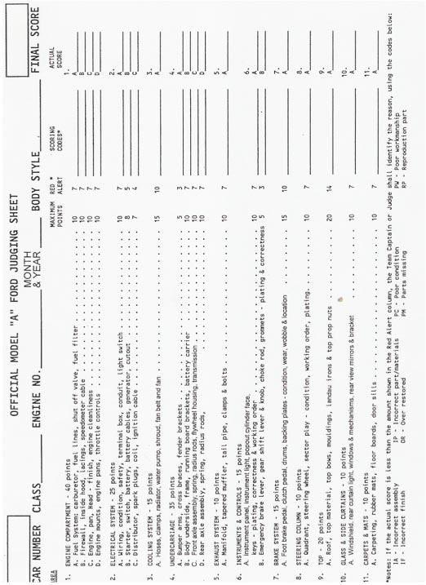
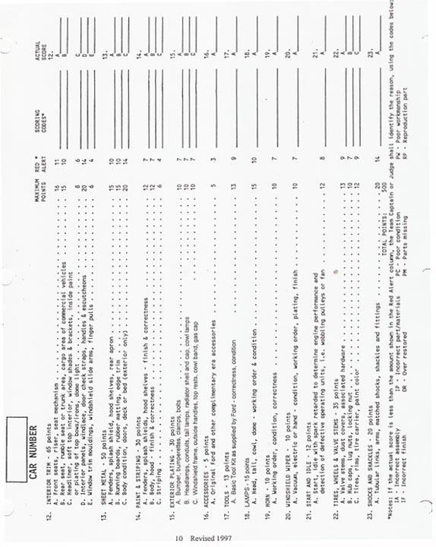

MODIFIED CLASS REQUIREMENTS

TOURING RED RIBBON
The touring includes any or all of the them:
1. Overdrives (torque tube type)
2. Fan and hub (belt driven)
3. Float-o-motor
4. Carburetor (updraft only)
5. Electrical/Ignition System including Halogen or sealed beam headlights behind A lenses and 12 volt conversion and/or an alternator.
6. Steering box with original style column
7. Rubber valve stems

MODIFIED GREEN RIBBON
A vehicle that has received more extensive modifications than those in the tour class. Acceptable modifications may include any or all of the tour class seven point items as listed in the tour class definition and in addition to one or more of the modifications listed below:
- A or B Engine block
- Era transmission (through 1939)
- Hydraulic brakes (through 1948)
- Wheels and tires must be appropriate for the 1928-1935 era and may be wire. wood spoked, disc and "jumbo".
- Modified steering boxes
- Oil, fuel and/or air filters
- Performance ignition/distributor system.
- All non-stock heads (fumed. aluminum. overhead)
- Pressurized cooling system permitted
- Paint color must be of a Model A 28-31 colors but need not conform to original factory combinations for the body style. No metallic. Splash aprons and fenders must be painted black. Speedsters colors may very due to era advertising requirements.
- Upholstery must remain original style seats for any appropriate body style. Era type material must be used.
- Intake manifold (up draft or down draft for a single or dual carburetors)
- Shocks are hydraulic or friction type only. no tube type.
- Model A body style cannot be chopped or channeled. Era type open wheeled speedsters acceptable. Basic chassis shall remain Model A
- All body parts shall be metal with no fiberglass components
- Era transmissions/rear axles (through 1939). No automatic transmissions.
- Era radiators acceptable. No electric fans.

GENERAL REQUIREMENTS
- Only speed equipment applicable to the Model A era is acceptable.
- Replica cars will not be recognized in this class.
- A separate 400 point judging sheet will be used for the modified class.
- Model A tools will not be required for modified class.
- Vehicles in the modified class must pass the start and idle parts and safety inspection of the scoring process.

Modified Judging Score Sheet

GENERAL:

The modified Class accommodates those members' of the club who appreciate the Model A, but prefer to alter their car with "improvements" in Safety, Comfort, Mechanical Reliability and Serviceability. It is important to determine a limit of modifications that tend to destroy the basic Model A appearance. Modifications are limited to ERA components or exact copies of components from 1928 to 1939. Selected safety components: I.E. hydraulic brakes can be allowed to 1948 for adaptability.

Cars are basically divided into two categories: Stock-bodied--cars that are registered for street use and Open wheel ERA type' speedsters that also includes Track cars. These will usually have no fenders and designed for racing and are custom built. All vehicles in this class must have an A or B engine block. Tools are not to be judged as part of this class. All cars must be part of the start and idle requirement and pass the equipment operation to identify possible safety concerns.

JUDGING PHILOSOPHY:

When judging in this class, consider authenticity of materials, hardware and assembly. It is important to consider quality of workmanship, cleanliness, condition of the components and working order. The scoring process has 400 available points divided into six categories. The intent is to keep close to the Model A Judging Standards and Guidelines as possible for all components that are not modified. The Model A "appearance" should relate to the MAFCA Restoration and Judging Guidelines as possible for each of the six modified categories, however, when judging each modification, the MAFCA Judging Standards become less comprehensive. The judge must be fair in awarding points in each area based on quality, authenticity (era), installation of components and cleanliness.

MODIFIED CLASS REQUIREMENTS

TOURING RED RIBBON
The touring class includes any or all of the following items:
1. Overdrives (torque tube type)
2. Fan and hub (belt driven)
3. Float-o-motor
4. Carburetor (updraft only)
5. Electrical/Ignition System including Halogen or sealed beam headlights behind A lenses.
and 12 volt conversion and/or an alternator.
6. Steering box with original style column
7. Rubber valve stems

MODIFIED GREEN RIBBON

A modified vehicle may have more extensive modifications than those permitted in the touring class. Although there is no limit on the number of modifications permitted in the modified class, only those modifications within the following area are acceptable:

- Modifications authorized in the touring class are allowed.
- Any Model A color(s) as per current revision of the Model A Ford Paint and Finish Guide. Fenders and splash aprons must be black. No metallic.
- Engine block must be either Ford A or B
- High compression, finned, aluminum or overhead valve cylinder heads are allowed.
- Any style of intake manifolds may be used, including single or multiple carburetors.
- An exhaust header may be used.
- Fuel pump, lines and filters may be used.
- No electric fans allowed.
- Engine lubrication system is allowed.
- Overdrive transmissions, 3 speed transmissions through 1939 and 2 speed rear axles are allowed. No automatic transmission.
- Shocks are hydraulic or friction type only, no tube type shocks.
- Hydraulic brakes are allowed.
- A pressurized radiator may be used.
- The steering system may be modified.
- Wheels and tires may be wire or wood spoked, disc or “jumbo” from 1928-1935 style.
- Upholstery must remain original style, appropriate for body style and use era type material only.
- Oil, fuel and/or air filters are allowed.
- The body must be Model A style (no chopped or channeled modifications). Basic chassis must remain Model A.
- All body parts must be metal. No fiberglass components are allowed.
- Speedsters may apply for variances of colors, body, fenders and etc. based upon era advertising or other evidence of authenticity.

General Requirements for Modified Class

  - The engine must be Model A or B. Only speed equipment applicable to the Model A era is acceptable.
  - Replica cars are not recognized in this class.
  - A separate 400 point judging sheet will be used for the modified class.
  - Model A tools are not required. No additional points are awarded for tools displayed.
Vehicles in the modified class must pass mechanical and Start & Idle as part of the scoring process.

MODIFIED CLASS JUDGING SCORE SHEET

REGISTRATION # ______________

BODY STYLE __________________ YEAR ____________

AREA 1 PERFORMANCE

A. START AND IDLE: MAXIMUM POINTS 20

The vehicle should start quickly with no hesitation. When revved up there should be no “dead” spot. The engine RPM should advance smoothly and quickly. The tail pipe should not show evidence of oil burning or running to rich. Not any wobbly pulleys: check the AMP gauge for positive charge rate. Engine should not knock at any time.

B. SAFETY CHECK: MAXIMUM POINTS 40

Inspect the following for condition and working order. All items should be is good operation.

EACH ITEM IS WORTH 4 POINTS

Safety Glass
All Lights
Emergency Brake Holds
Fan Belt Cracks
Loose Steering
Horn Function
Loose Battery
Tire Wear/Condition
Windshield Wiper Blades
Frayed or Exposed Wiring

SCORE_____ INITIALS____

COMMENTS ____________________________________________________________________________________________

SCORE_____ INITIALS____

COMMENTS ____________________________________________________________________________________________

MODIFIED CLASS JUDGING SCORE SHEET

REGISTRATION # ______________

BODY STYLE __________________ YEAR ____________

AREA 2
APPERANCE AND DETAIL

In this area, look at the car from all sides for congruency and appearance. Detail to workmanship is important. Also consider how well a modification is installed. How well it fits and operates, neat in appearance and no evidence of wear. If a car does not have a good modification in a particular area, judge per MAFCA Guidelines for that area.

- WORKMANSHIP AND APPEARANCE

Check the vehicle stance, bumpers even, springs do not sag and shackles not worn. Headlights are even and running boards are level and no broken braces.
MAXIMUM POINTS 20

Doors, hood, top, rumble lid fit, fender beads straight with good fit to corresponding parts. Cars that were built for the race track will receive full points for fenders.
MAXIMUM POINTS 20

- MODIFICATION APPLICATION

Determine how well modifications were installed. Hoses, wiring and cables are installed properly. Proper “like kind” fasteners, wire ties and clamps are uniform and installed correctly.
MAXIMUM POINTS 20

EACH ITEM IS WORTH 4 POINTS

Safety Glass
All Lights
Emergency Brake Holds
Fan Belt Cracks
Loose Steering
Horn Function
Loose Battery
Tire Wear/Condition
Windshield Wiper Blades
Frayed or Exposed Wiring

SCORE_____ INITIALS____

COMMENTS _____________________________________________________________________

SCORE_____ INITIALS____

COMMENTS _____________________________________________________________________

SCORE_____ INITIALS____

COMMENTS _____________________________________________________________________

MODIFIED CLASS JUDGING SCORE SHEET

REGISTRATION # ______________

BODY STYLE __________________ YEAR ____________

AREA 3
PAINT AND FINISH

Any Model A color from 1928-1931 is acceptable. If a non stock color is used, a variance must be required. I.E. a speedster is painted for sponsorship. No metallic paint is allowed. Fendered cars must have black fenders.

- ALL SURFACES AND CONDITIONS
MAXIMUM POINTS 30

Dents, Filler Application, Hood seams.

- MODEL A COLOR 1928 - 1931
MAXIMUM POINTS 20

Free from runs, Dirt in paint, Cracks, Blisters and Scratches.

- FENDERS
MAXIMUM POINTS 20

Painted black with body welt installation and condition. Cars that were built for racing and have no fenders will receive full points.

SCORE_____ INITIALS____

COMMENTS _____________________________________________________________________

SCORE_____ INITIALS____

COMMENTS _____________________________________________________________________

SCORE_____ INITIALS____

COMMENTS _____________________________________________________________________

MODIFIED CLASS JUDGING SCORE SHEET

REGISTRATION # ______________

BODY STYLE __________________ YEAR ____________

AREA 4
UPHOLSTERY AND TOP

Check for workmanship and fit of all spring covers. Foam foundation should be marked down. Seats should not sag and be anchored to the floor. Pleated seats should line up with top and bottom cushions. Open cars must have leather as original. Mark down for Naugahyde plastic type covering material.

- SEATING SPRING
MAXIMUM POINTS 10
Condition and fit of covers.

- ANY 1928-1931 MODEL A FABRIC OR LEATHER MATERIAL COVERINGS.

MAXIMUM POINTS 20

- TOP MATERIAL FIT AND CONDITION,
Includes Top Moldings, Bindings, and Side Curtains. Cars designed for racing will get full points.
MAXIMUM POINTS 20

- FIT AND WORKMANSHIP OF DOOR PANELS, Rumble Seat area, Headliner and Carpets. Window regulators operate smoothly. Interior Hardware Plating.
MAXIMUM POINTS 20

SCORE_____ INITIALS____

COMMENTS ______________________________________________

SCORE_____ INITIALS____

COMMENTS ______________________________________________

SCORE_____ INITIALS____

COMMENTS _______________________

_______________________

SCORE_____ INITIALS____

COMMENTS ______________________________________________

MODIFIED CLASS JUDGING SCORE SHEET

REGISTRATION # ______________

BODY STYLE __________________ YEAR ____________
AREA 5
ENGINE COMPARTMENT
Only A or B engine blocks permitted. All engine components should be clean with no evidence of gas or oil leaks. Fire wall should have no extra holes and cowl lacing installed properly. Era components are from 1928-1939 only. All modifications should include only era items or exact copies of era components including overhead valves, intake manifolds, special carburetors, etc.

- FORD MODEL A OR B ENGINE BLOCK
MAXIMUM POINTS 20
Engine components are clean with no gas, water, or oil leaks. Gaskets not painted over, water hoses free from cracks or kinks with no kinks in the hose and era clamps. Plastic fans permitted as a safety item.

- FIREWALL CONDITION AND LACING
MAXIMUM POINTS 10
Check for cracks, extra holes and braces. All modifications on the firewall must coordinate with a component of the vehicle and be operational.

- ENGINE ELECTRICAL
MAXIMUM POINTS 20
All wires are neat with ties and clips where appropriate. Plastic wiring takes a deduction, only fabric covered wiring is era. Plastic fuse holders are permitted as a safety item. Plastic ties are permitted. Alternators and Mallory distributors are non era but are approved for the class.

- FUEL SYSTEMS/CARBS
MAXIMUM POINTS 20
Fuel lines are copper or steel with rubber used as a vibration dampener only. No leaks. Era cards from 1929-1939 are permitted. Non stock cards require an additional return spring.

SCORE_____ INITIALS____

COMMENTS ______________________________________________

SCORE_____ INITIALS____

COMMENTS ______________________________________________

SCORE_____ INITIALS____

COMMENTS _______________________

_______________________

SCORE_____ INITIALS____

COMMENTS ______________________________________________

MODIFIED CLASS JUDGING SCORE SHEET

REGISTRATION # ______________

BODY STYLE __________________ YEAR ____________

AREA 6
UNDERCARRIAGE

Including all items visible under the car except the engine compartment area. Transmission, differential must be era 1928-1939. Brakes can include hydraulic to 1948. Radial tires and improved steering boxes are not era, but are safety and are allowed. Overdrives and era two speed differentials are acceptable.

- WHEELS AND SCHOCKS
MAXIMUM POINTS 20

Wheels to be era 1928-1935. reverse rims or mag wheels are not acceptable. Shocks are friction type or hydraulic.

- EXHAUST SYSTEM
MAXIMUM POINTS 20
To include proper hangers of the era. Muffler installed neat in appearance with no exhaust leaks or tail pipes rubbing on the frame. Exhaust system to be free from rust and no welding cracks.

- SUSPENSION COMPONENTS
MAXIMUM POINTS 20
Check wear of spring shackles. All cotter pins installed the same through out the chassis. All components do not leak fluids, and are clean. Cables/wiring have proper clips and ties. Judge non modified components to the MAFCA Judging Guidelines.

SCORE_____ INITIALS____

COMMENTS ______________________________________________

SCORE_____ INITIALS____

COMMENTS _______________________

_______________________

SCORE_____ INITIALS____

COMMENTS ______________________________________________
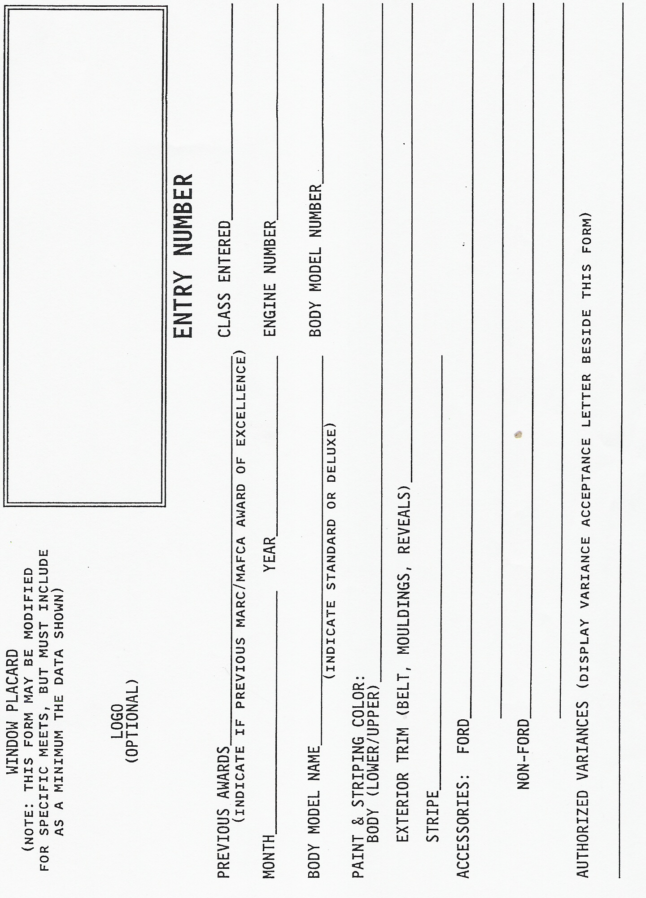
NATIONAL MEET REQUIREMENTS FOR FINAL JUDGING OF VEHICLES

- Make sure a car entry number card is mounted on the windshield. The proper completion of the entry number card is the responsibility of the individual entering a vehicle for judging. To avoid misunderstandings in judging accessories, owners shall list on the entry number card all items on the vehicle, which they consider to be accessories and wish to be judged as such. The entry number card will be in the registration package.

- All authorized variances must be displayed on the windshield. No additional notes or comments are allowed.

- If drive-through judging is used, cars must be driven through the judging area by the driver only; no passengers. The driver must leave the vehicle at judging stations, if requested.

- If stationary judging in buildings is used, cars must be secured to conform to local fire safety codes.

- On all open models, the top must be up with the rear window secured.

- Mount side curtains on right side of open vehicles (passenger side). Left side curtains, irons and top straps must be available for inspection and should be left in the back seat, rumble seat, trunk or bed of pickup box.

- Unhook all hood clamps.

- Remove pedal pads and all metal or fabric tire covers (if any).

- All applicable keys should be on a single key ring and left in the ignition switch.

- The owner's manual, tool bag and tools must be available for inspection and must be loosely displayed to allow a judge to examine or check forging or stamp markings. (Do not mount securely on display. board or case.) Tools will not be checked for function.

WHEN INDIVIDUAL AREA JUDGING SHEETS ARE USED THIS FORM WILL ASSIST THE QUALITY ASSURANCE PERSON(S) TO CHECK OFF THE SHETS AS THEY ARE TURNED IN BY THE JUDGING TEAMS.

QUALITY ASSURANCE CHECK OFF LIST

Registration # (circle appropriate letter when judging sheet has gone to Tally)

___________ A B C D E F G H I

___________ A B C D E F G H I

___________ A B C D E F G H I

___________ A B C D E F G H I

___________ A B C D E F G H I

___________ A B C D E F G H I

___________ A B C D E F G H I

___________ A B C D E F G H I

___________ A B C D E F G H I

___________ A B C D E F G H I

___________ A B C D E F G H I

___________ A B C D E F G H I

___________ A B C D E F G H I

___________ A B C D E F G H I

___________ A B C D E F G H I

___________ A B C D E F G H I

___________ A B C D E F G H I

___________ A B C D E F G H I

___________ A B C D E F G H I
MAFCA JUDGE EVALUATION

JUDGE NAME: _________________________________________________
ADDRESS: _________________________________________________
_________________________________________________
MEET: _________________________________________________
JEDGE CLASSIFICATION:_________________________________________________
AREA JUDGED: _________________________________________________
RATING
(rank on scale of 1(poor) to 10 (Excellent)

SUBJECT KNOWLEDGE: _________________________________________________
PREPARATION: _________________________________________________
ATTENTIVENESS: _________________________________________________
CONSISTANCY: _________________________________________________
IMPARTIALITY: _________________________________________________
THOROUGHNESS: _________________________________________________
DECISIVENESS: _________________________________________________
ABILITY TO WORK WITH OTHERS: _________________________________________

OVERALL EVALUATION BY TEAM CAPTAIN:
_______________________________________________________________________
_______________________________________________________________________
_______________________________________________________________________
_______________________________________________________________________
_______________________________________________________________________
_______________________________________________________________________

____________________ _________________________________
(Date) (Team Captain)

