Area 4 - Undercarriage

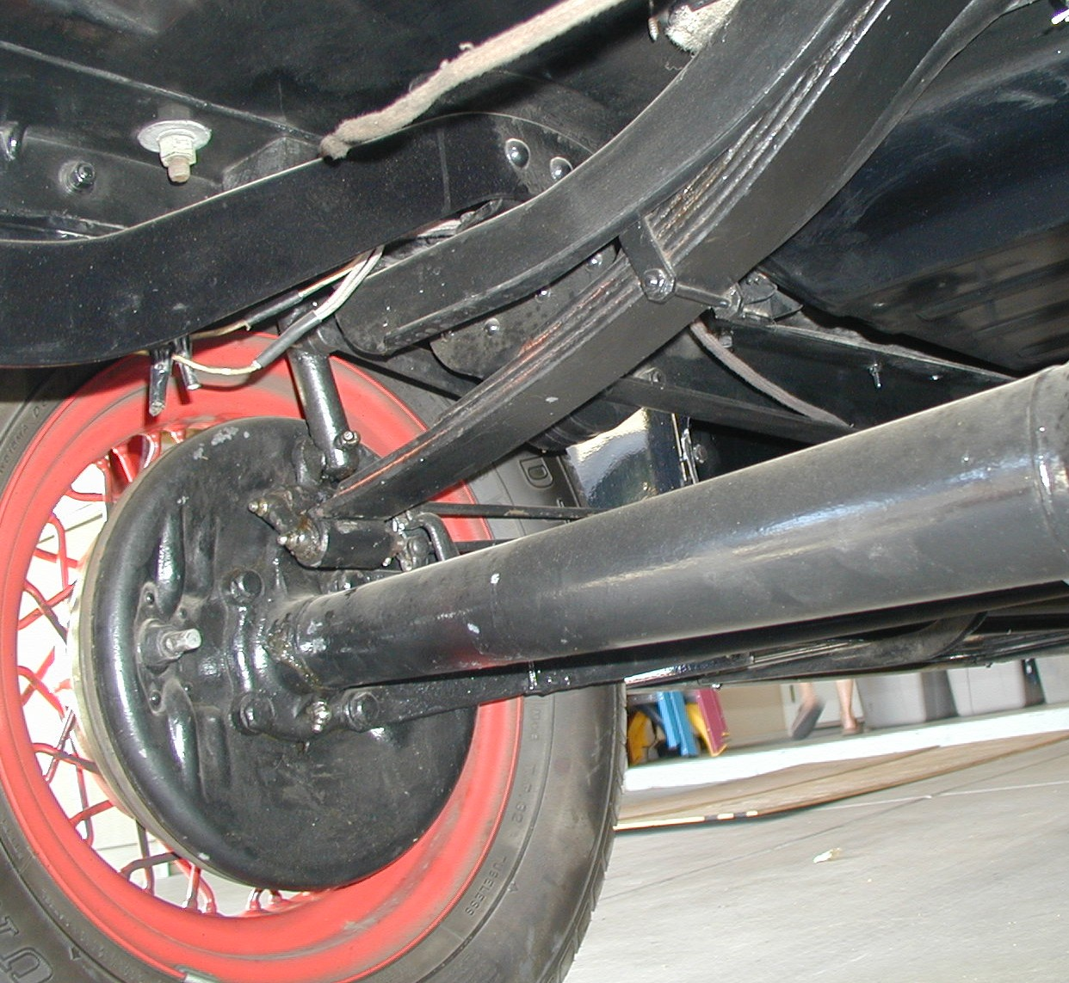
INCLUDES: frame and cross members, axles, springs,
radius rods, steering linkage, battery box, transmission,
torque tube, running board and fender brackets, bumper
arms and cross braces, flywheel housing, proper grease fittings, and underside of the body for correctness, finishes, , etc.

Does not include: wheels, brake drums, backing plates,
brake rods, brake cross shafts, spring hangers (shackles),
shocks, exhaust system, running boards, or bumpers.

TOTAL POINTS: 30

GENERAL
Make sure cotter pins are neatly installed where required, and loose fitting in linkages. Finish, workmanship, plating, materials and correctness should be foremost in judging. For authenticity of the various components judged in this area, refer to the current Model A Restoration Guidelines and Judging Standards. A good reproduction part shall receive 50% of the points for that item, but a modern part (after 1939) will receive 0 points.

UNDERCARRIAGE MAX. PTS. SCORE CODE

Frame and members (If not a Model A frame, 0 pts) ___ 5___ ________ _____

Axles and torque tube (Era overdrives like Borg- ____ 5___ ________ _____
Warner, axles through 1939 like Columbia)

Underside of body (finishes, cleanliness) ____ 4___ ________ _____

Transmission and flywheel housing (Era through ___ _3___ ________ _____
1939. Automatic, 4 or 5 speed receive 0 points)

Steering linkage ___ _3___ ________ _____

Radius rods ____ 2___ ________ _____

Springs ____ 2___ ________ _____

UNDERCARRIAGE MAX. PTS. SCORE CODE

Battery box (Check for corrosion. If not under ____ 2___ ________ _____
floor, 0 pts.)

Running board and fender brackets ____ 2___ ________ _____

Bumper arms and cross braces ____ 2___ ________ _____

TOTALS ___ 30_ _ ________

Team Captain signature: ___________________________

