Member Profile – John Lavoy

In 1961 I became interested in Model As. A buddy in high school had a basket case Cabriolet he was working on and talked me into getting a 1929 Coupe. The coupe got a little work done to it, but nothing fancy, painted, 21” wheels and tires, tuck and roll upholstery. But the more involved I got with Model As, the more I knew I wanted first, a convertible and second, one with a back seat so more people could ride with me. In 1965, I found a 1928 phaeton basket case.

I bought the car in the summer of 1965. Being young and enthusiastic, I decided I would get it restored (remember I said it was a basket case) and drive it to the MAFCA national in Albuquerque NM in the summer of 1966. Well, through assistance from the local Golden Feather Model A Club and my own perseverance, the job got done. There were two other Model As on that trip, the father of the Golden Feather Larry Sears and his wife Laverne, and Bentley and Edna Rae Conway, who took me under their wing and guided me through my formative years of Model A ownership.

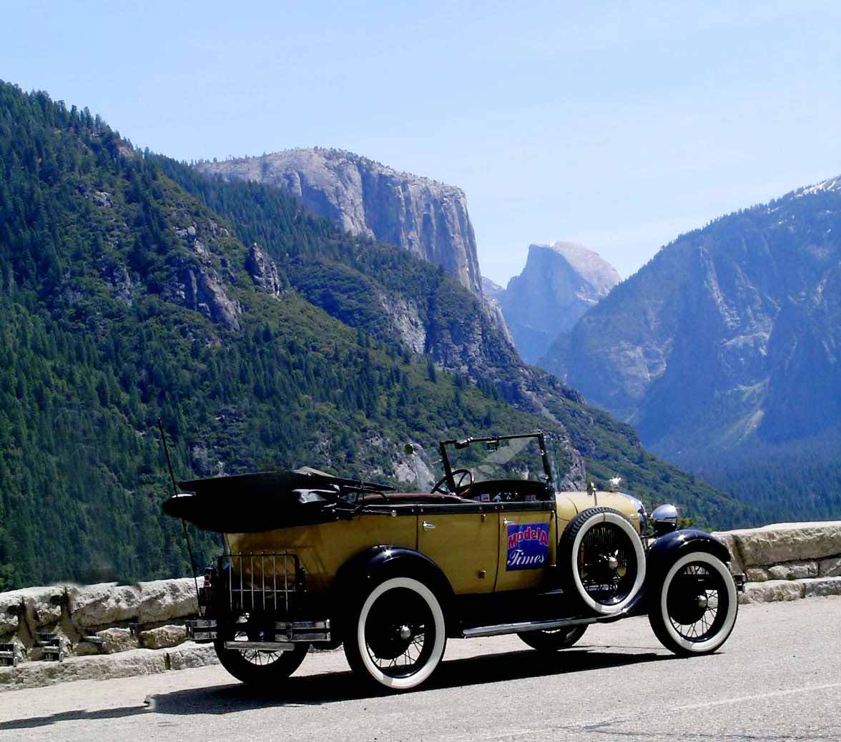
Like others who tell their story I still have the car. I still see Bentley from time to time; the rest of the folks have gone on ahead to the great Model A garage in the sky. But the phaeton has been an important part of my life and was implemental in creating the family I have. I met my wife Trish because of the phaeton, the car was in our wedding and our daughter’s too.

I am looking forward to doing a re- restoration on the car at some point. I may even take longer than a year to complete the process. But our phaeton has served us well taking us to Model A events and even non-Model A vacations for years.

Remember the “buddy” that talked me into getting the 1929 coupe? I ran into him, not too long ago, at a high school reunion. He sold the basket case while in college and lost interest in the Model A. I guess after he got me bitten by the Model A bug, he could move on!

This picture was taken on the last tour we used the phaeton; it was in 2008 to Yosemite Park while on the Central Coast Regional Meet. After this tour, we started using the 1929 Town Sedan that we had just finished restoring for long tours like to the MAFCA/MARC meet in Texas in 2008 (my wife wanted roll up windows after all these years). Look forward to seeing you all along the Model A Highway. It is the Journey….Not the Destination!

John & Trish LaVoy
Rocklin, CA
john@modelatimes.com

